Seneca Highlands Career Portfolios
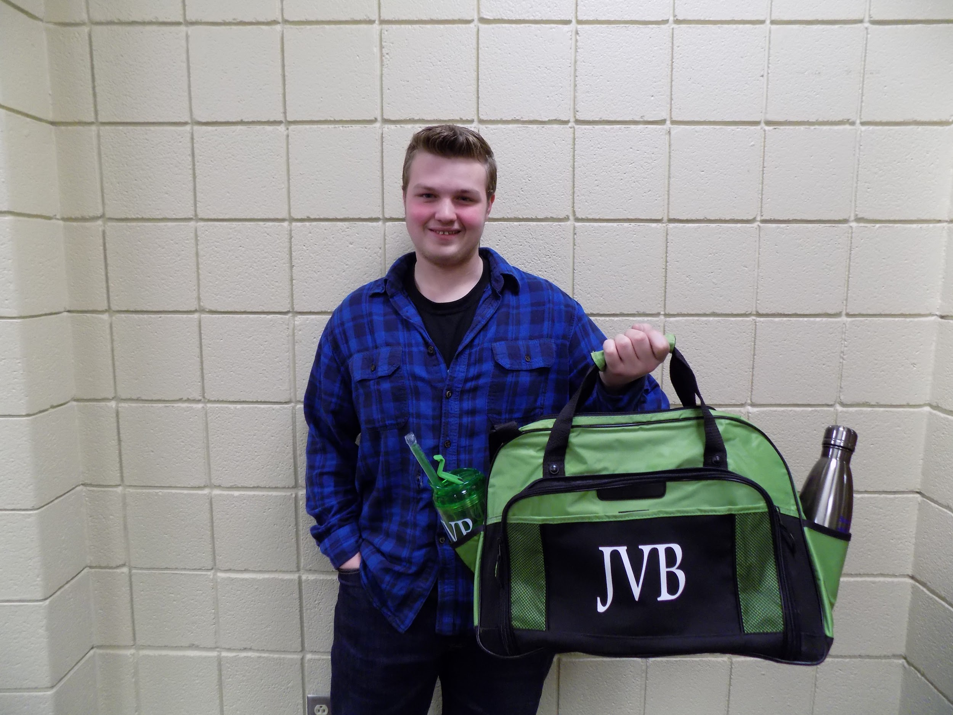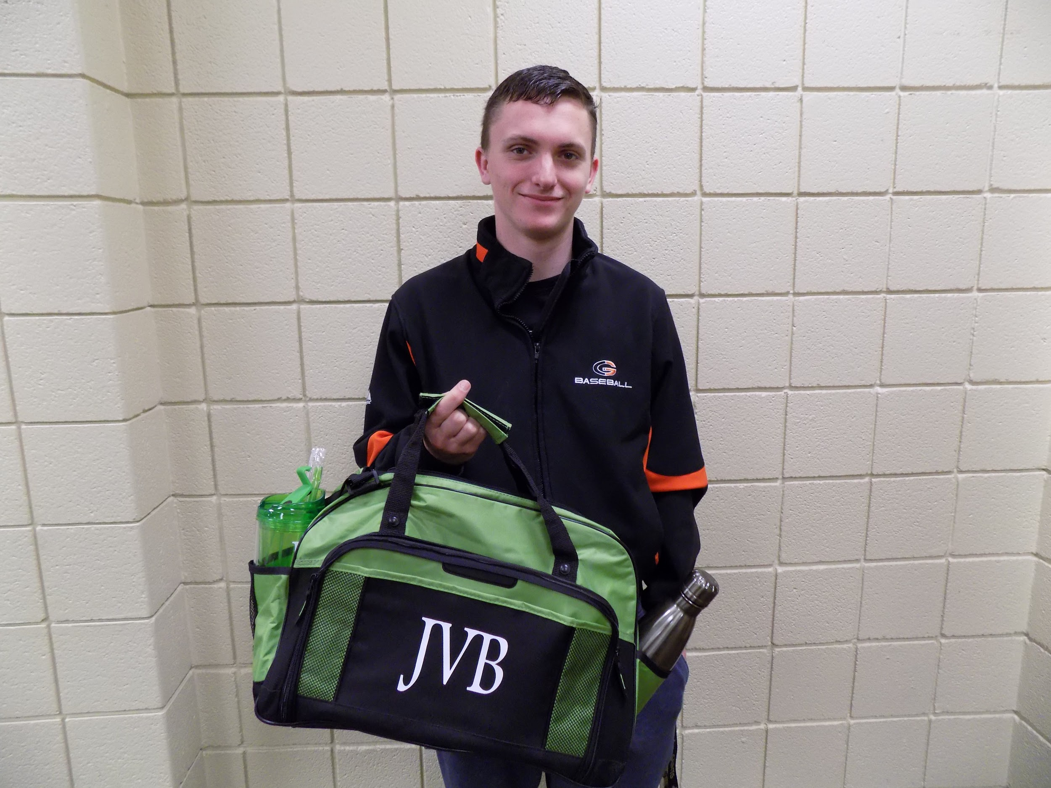
Dean Johnson, Cameron County, Automotive Gage Emerson, Port Allegany. Building Construction

Recently, the students at the Seneca Highlands Career and Technical Center began the process of creating Career Portfolios. The portfolios allowed the students to begin to organize career related materials in which the students could present to schools of continuing education and/potential employers. Portfolios could contain all of the student’s accomplishments, most recent ones being the best, and any other materials the student deemed relevant. Some examples of materials gathered/created for the portfolio included resumes, transcripts, letters of recommendations, work samples, pictures of the student completing skills, awards/achievements, any certifications, community/volunteer experience, and/or work experience.

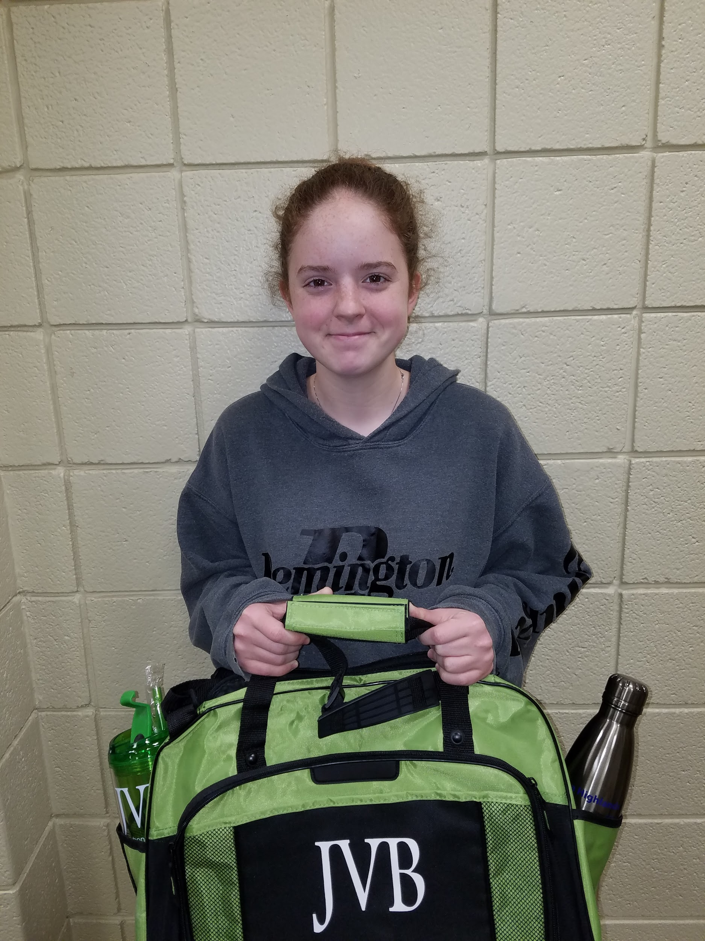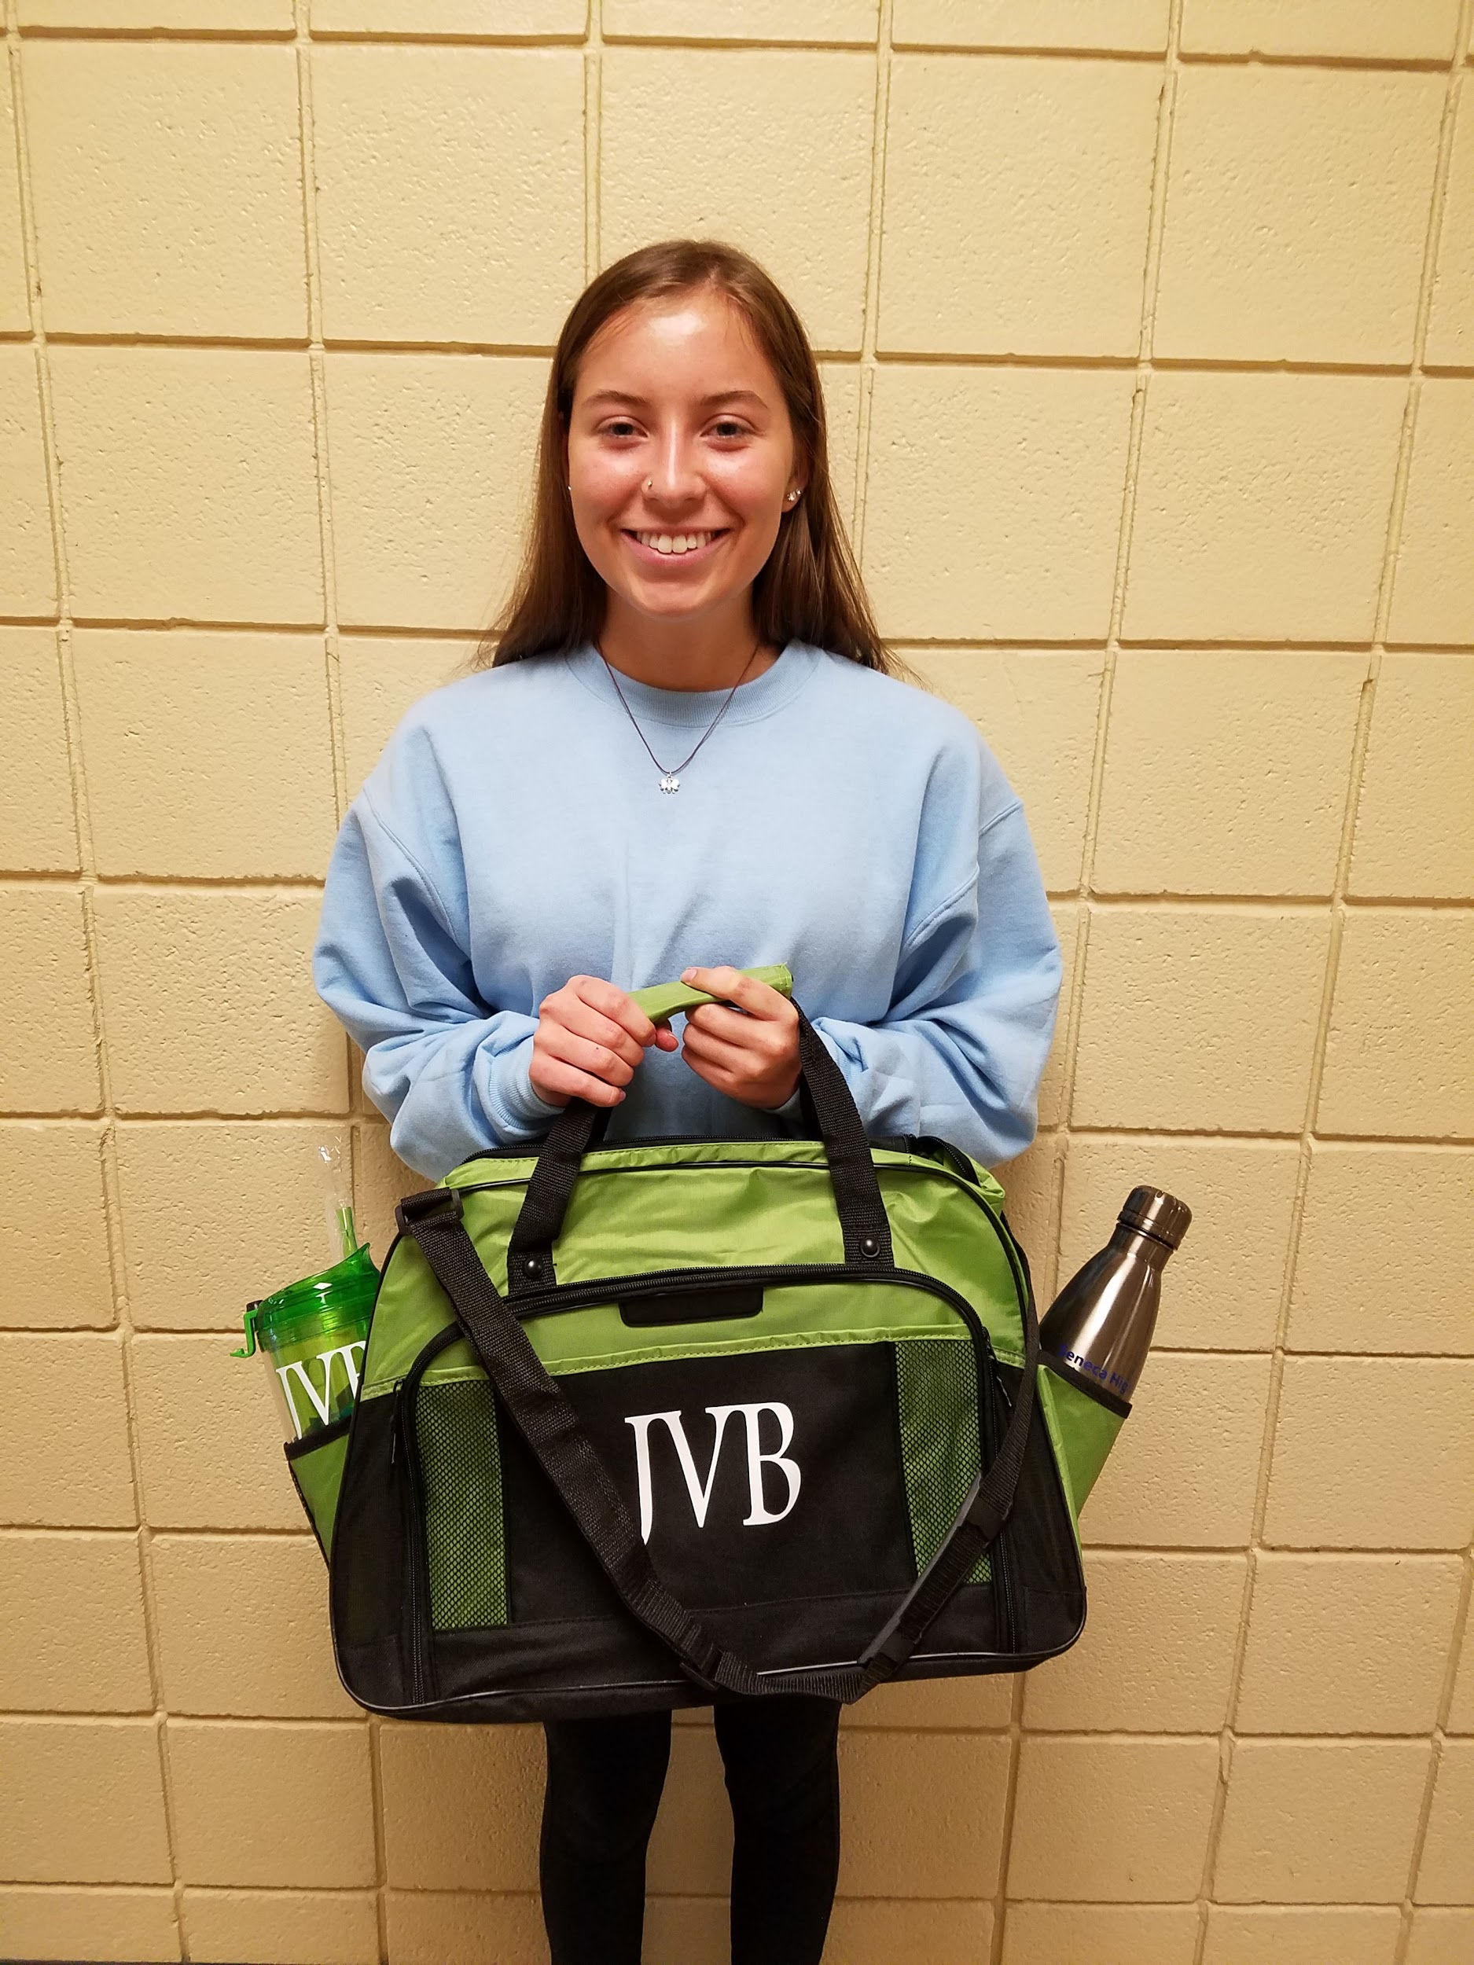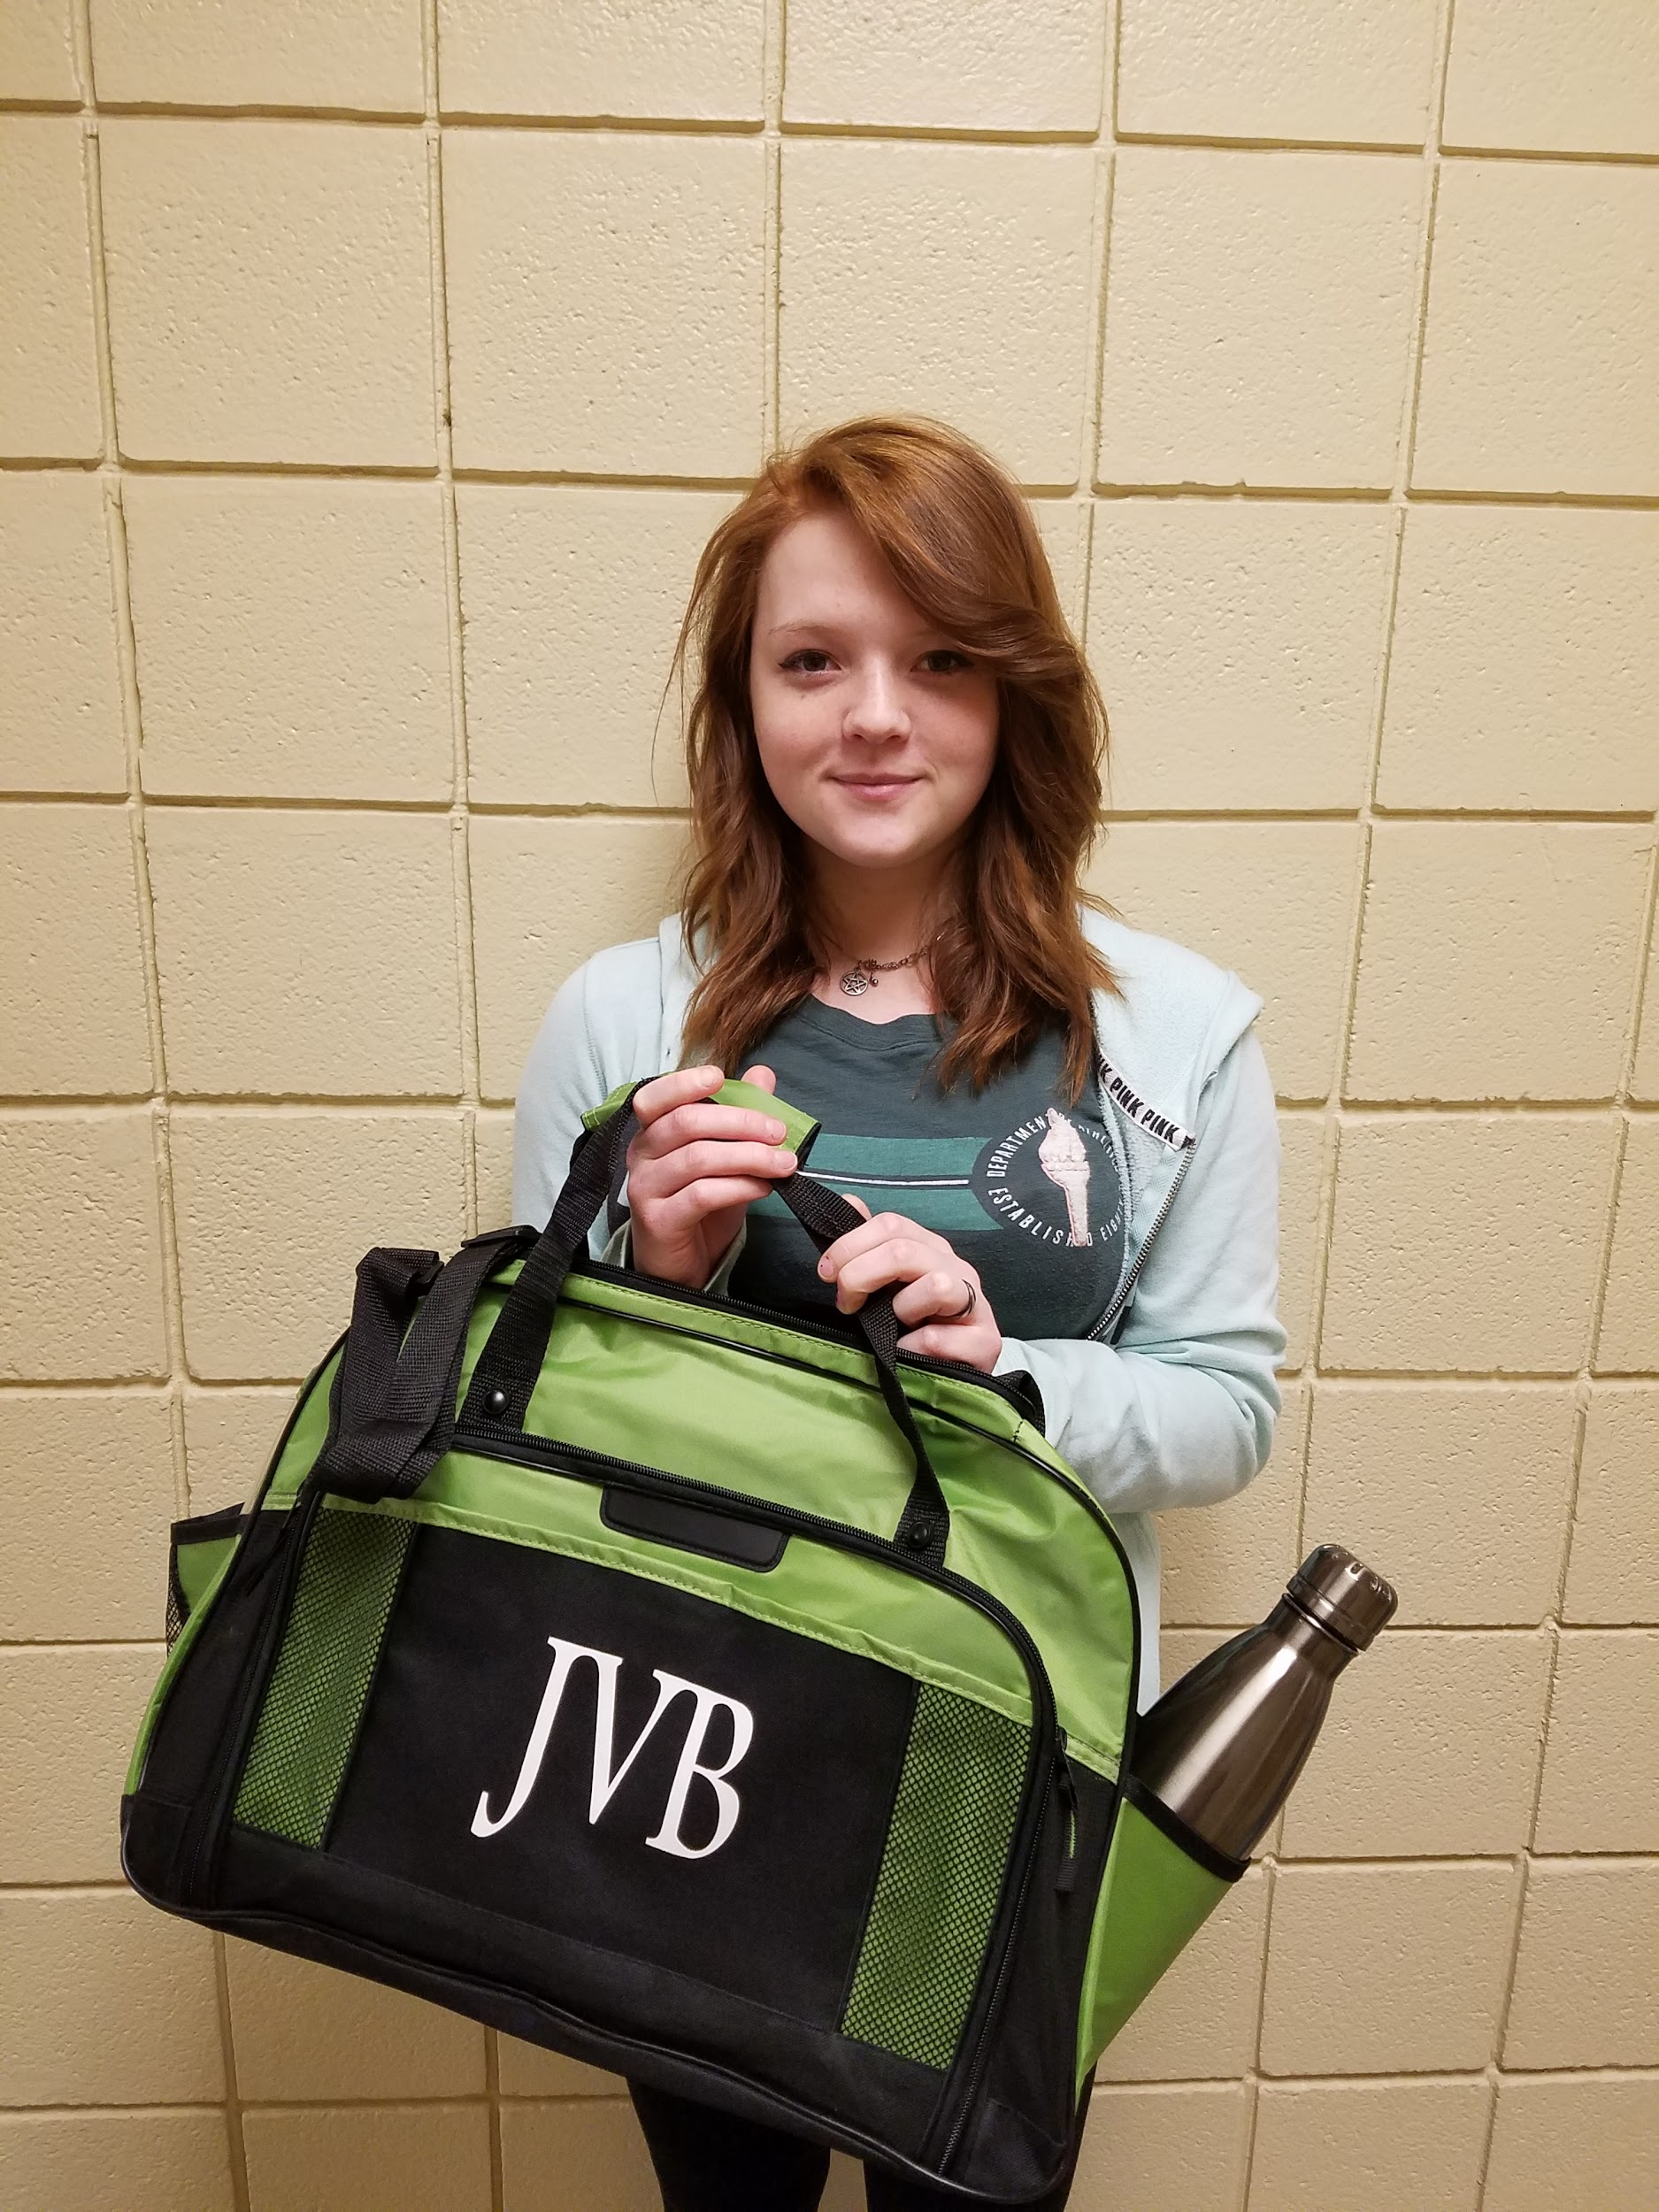
Angelique Streck, Coudersport Rylee Hooftallen, Austin Katrina Vulgamore, Smethport
Health Assistants Networking Culinary
So Why Are These Career Portfolios So Important?

Implementation of the student Career Portfolio not only gives the students an edge for school to work or school to secondary education, but it follows career and work standards, career pathways, and preparing students for interviews. It also aligns with the K-12 Guidance Plan and Every Student Succeeds Act (ESSA), through the Department of Education. It is an essential part of the student’s curriculum here at SHCTC and it will benefit those greatly that choose to put the time and effort into creating well thought out and put together portfolios.

Julian Watson, Austin, Welding

What Was In It for the Students?
All of the students that participated and submitted their portfolios this year were judged by the various instructors in the building. One student from each shop was selected as the overall winner as having the best put together portfolio. They each received a JVB bag filled with 2 shirts, a Sheetz card, some had hats, and water bottles.
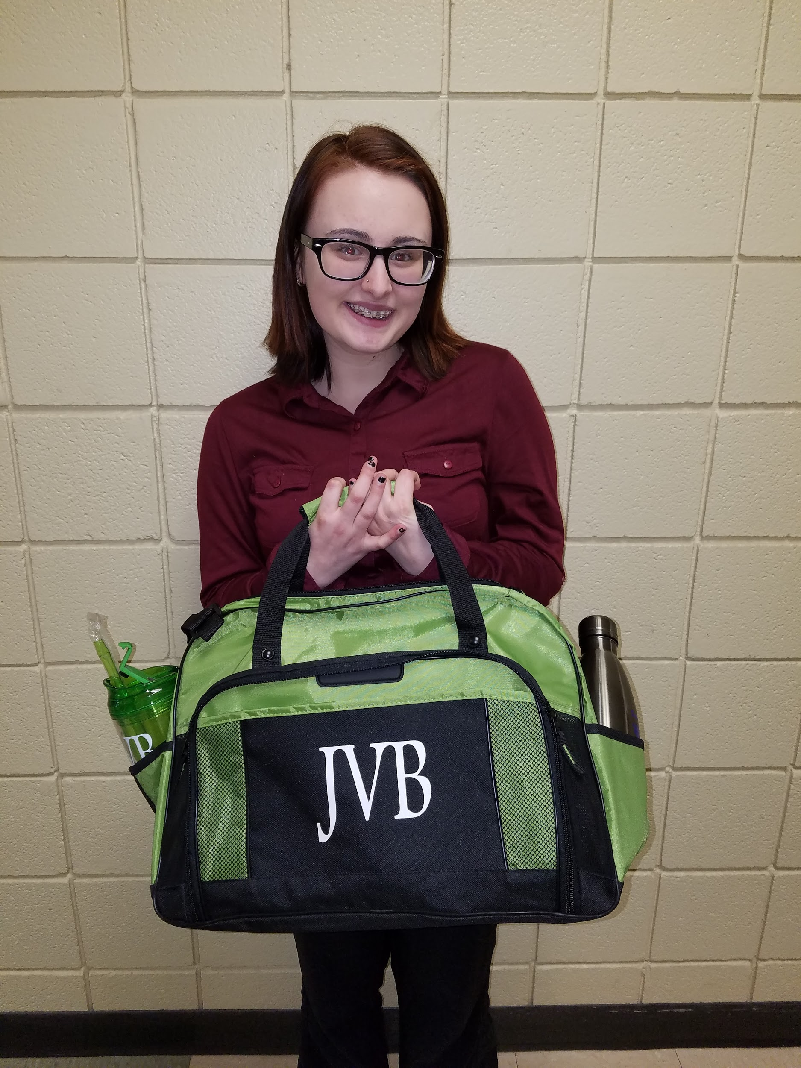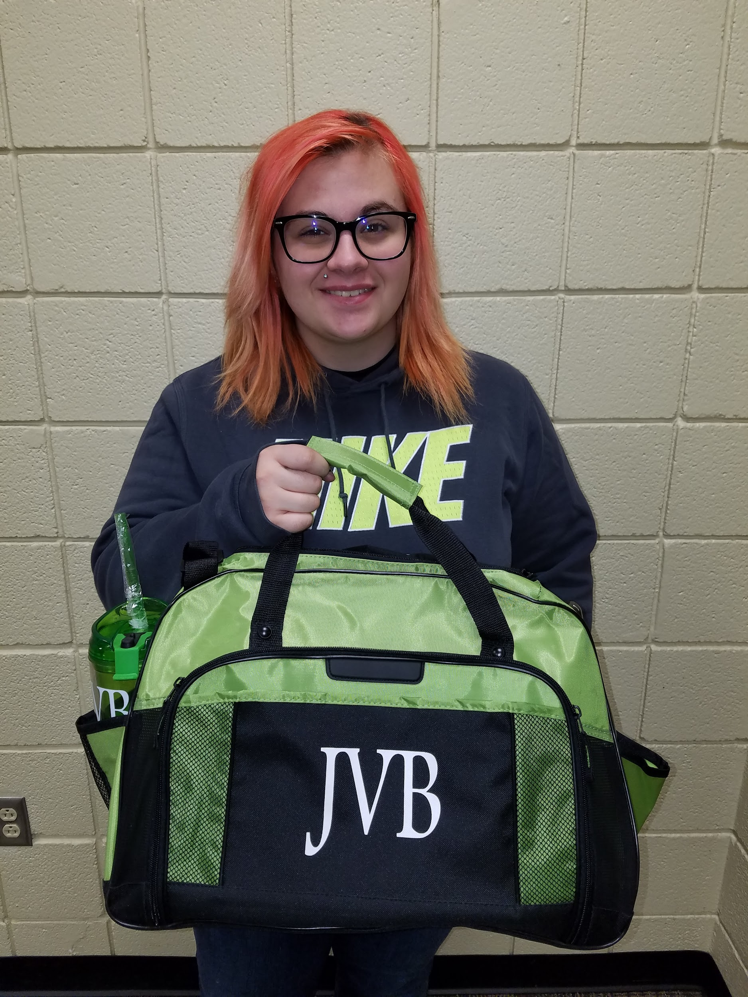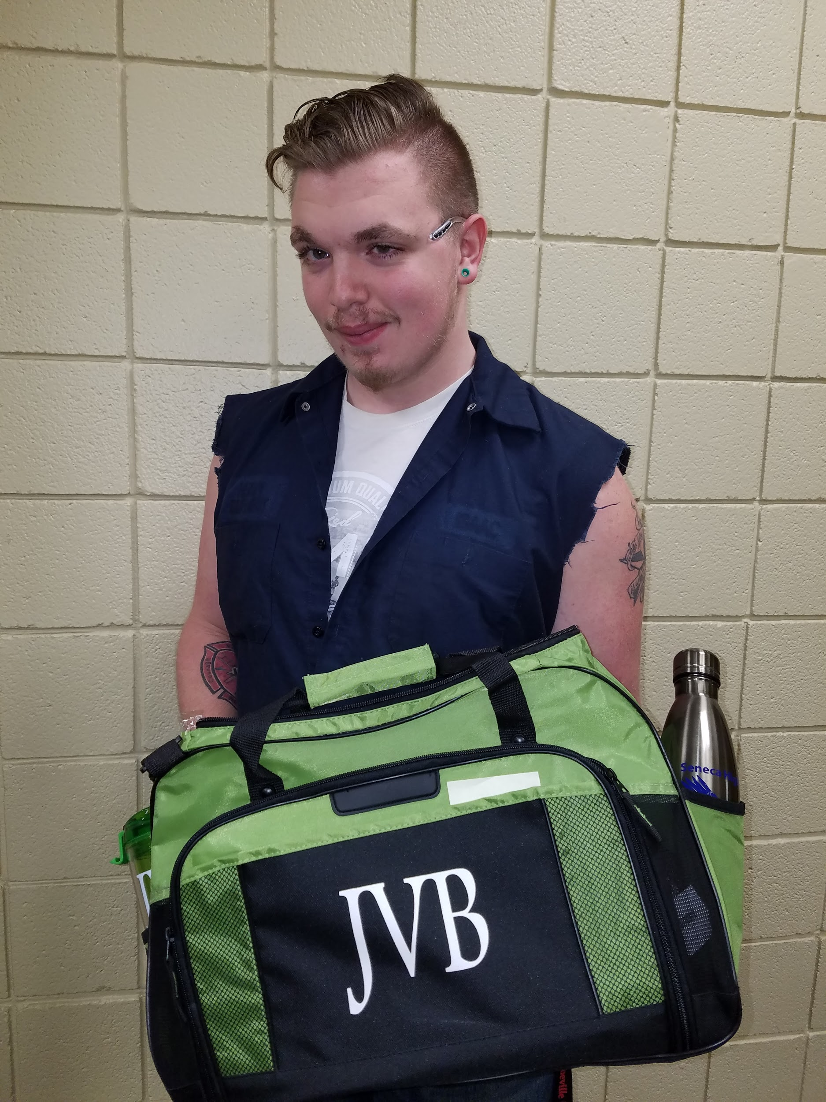
Destiny Mitchell, Austin Delleny Molisani, Northern Potter Isaac Fuller, Smethport
Early Childhood Education Metalworking Heavy Equipment

