Electrical Occupations After-School Program
When: March 20, 26, 28 & April 2, 4, 8, 2019
*Please note the dates have changed!
Time: 3:00 p.m.-5:00 p.m.
Location: Connellsville Area Career & Technical Center
Grade: Current CAMS 6th-8th graders
Cost: FREE!
Great opportunity for middle school students to experience an in-depth, hands-on exploration of the electrical occupations field!
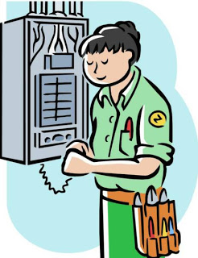
After-School Program Features:
- Exploration of the electrical occupations career path
- Instructor-led, hands-on workshops
- Free t-shirt for all participants
- Snacks provided every session

