Masonry Lab
POS Task 1203 and 1204
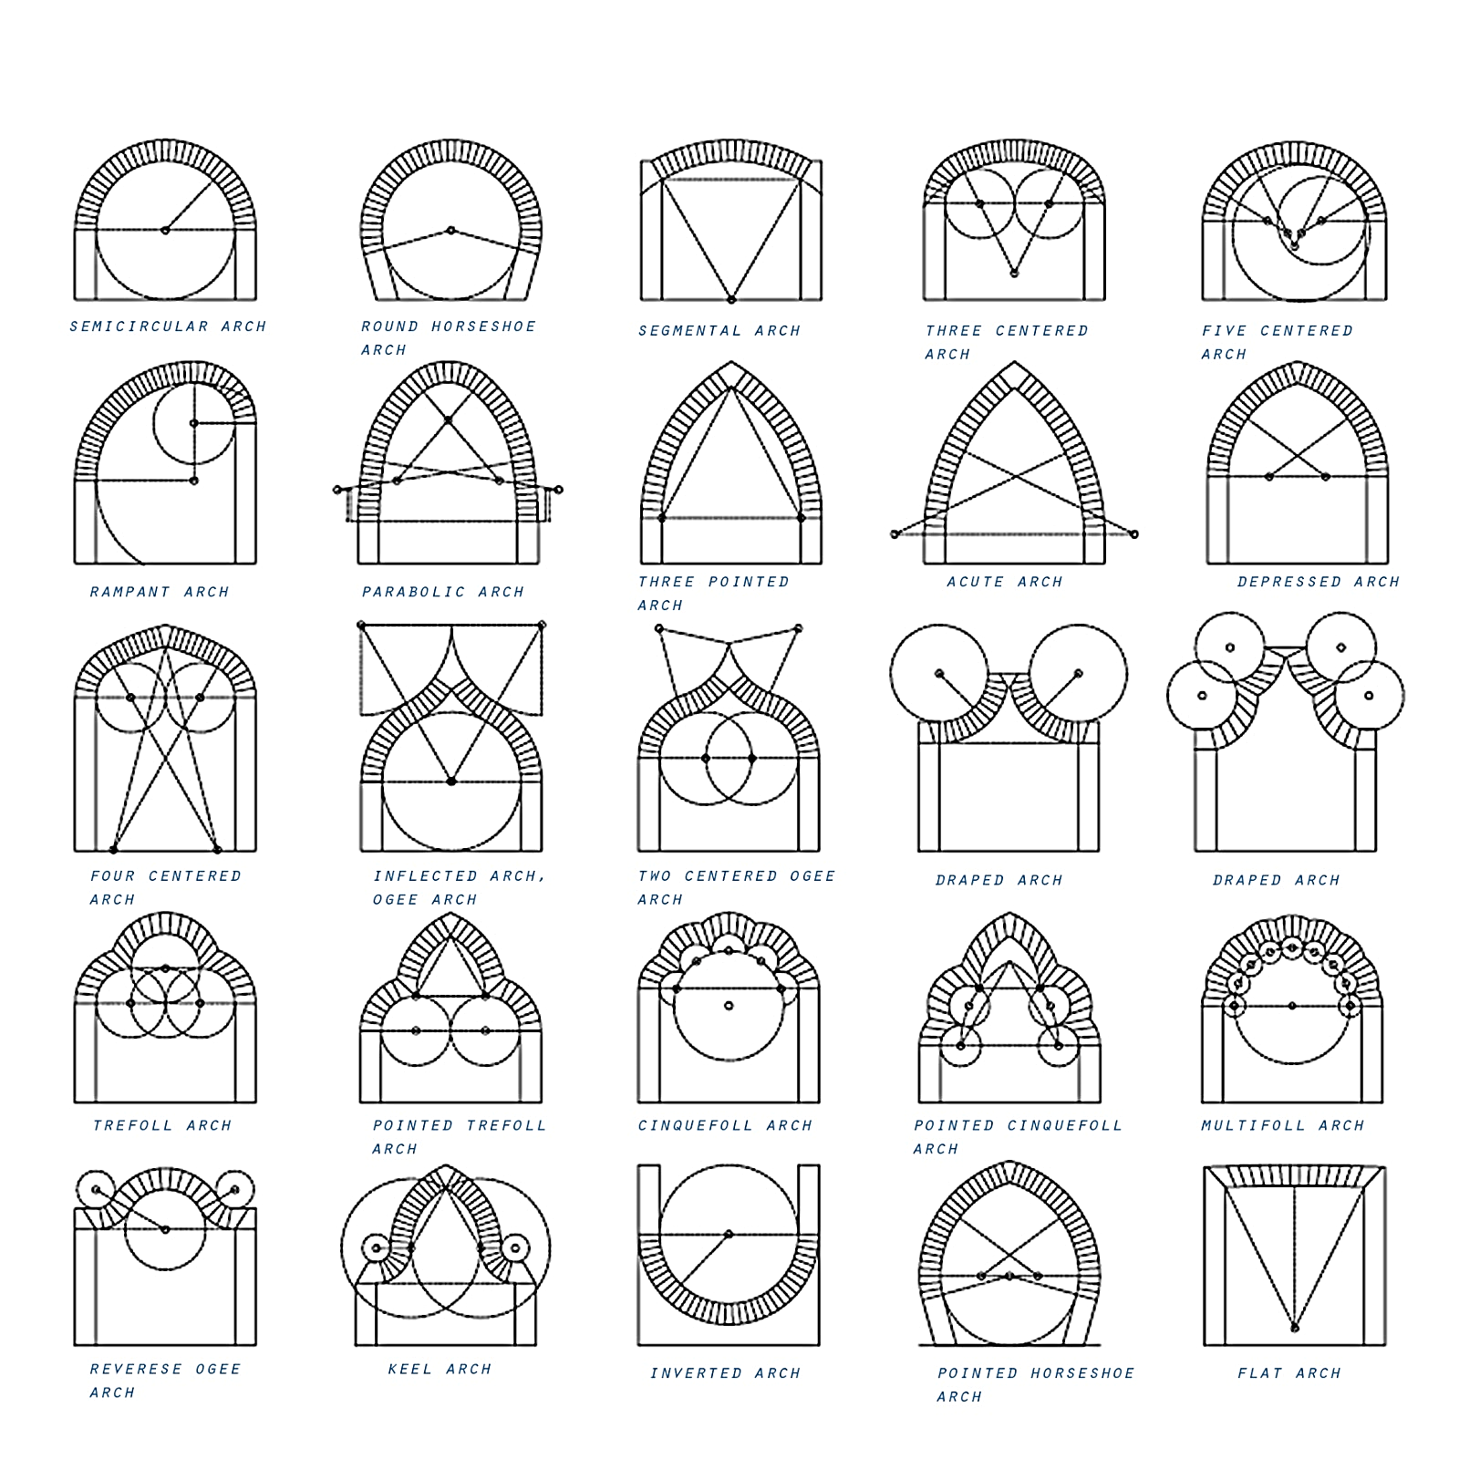
Arch Layout Points and Circles

