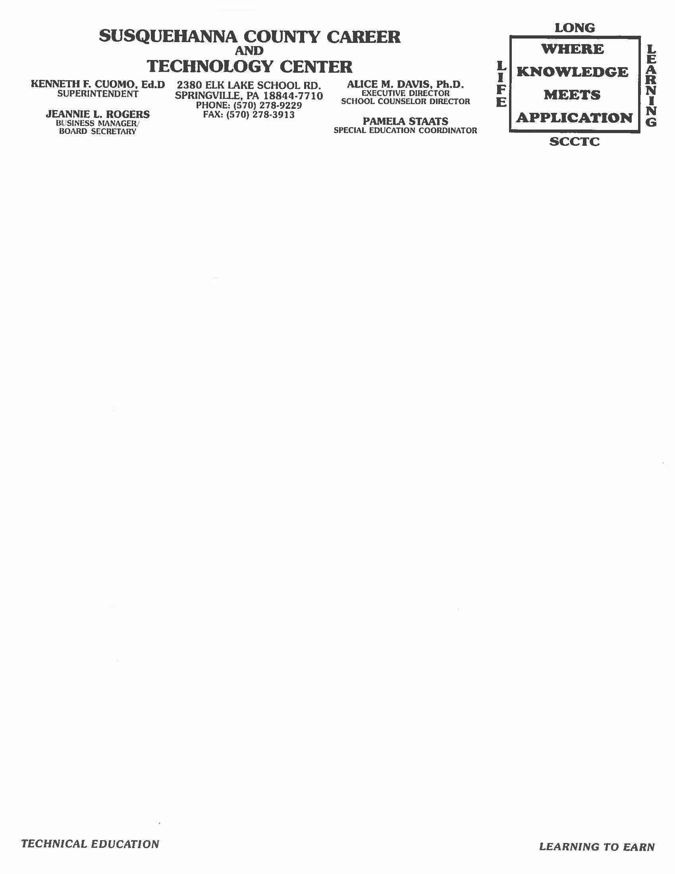

Alert Form Procedure

Step One

- An Alert Form is necessary if a student’s grade falls below a “C” – less than 74%
- The Alert form is a weekly Alert – date accordingly
- Teacher fills out Alert Form with student information including current grade
- A brief description of reason for low grade is given
- Teacher discusses Plan of Action with paraprofessional(s)
- Teacher fills in Plan of Action on Alert Form
- Teacher and paraprofessional(s) sign Alert Form
- Paraprofessional(s) initial after Plan of Action has been discussed with Teacher
- Alert form is than discussed with the named student
- Student than signs Alert Form- accepting notification of grade
- The Executive Director of the SCCTC signs Alert Form
- Original Alert Form is kept in the School Counselor’s Office filed alphabetically by Program Area in [ Label Tab “Incomplete Alert Form”]

Step Two

- A copy of the Alert Form is given to the School Counselor
- School Counselor will meet with the student if necessary
- A copy of the Alert Form is given to the Discipline Officer if attendance is a concern and he/she will contact the sending school
- A copy of the Alert Form is given to the paraprofessional(s) in order to document the students’ progress towards completion of the Plan of Action (notes are written on back of Alert Form copy- on a daily basis)
- Once Plan of Action is complete the copy/copies (from Paraprofessional(s), School Counselor and Discipline Officer when applicable) of the Alert Form is given back to the School Counselor’s Office and the copies are attached to the original which is then moved from “Incomplete Alert” to new [ Label Tab “Completed Alert Form”] and filed in the completed section (Alphabetically) of appropriate Program Area

2nd Alert Form Received on a Student

- Follow Step 1 and Step 2 up to the last step of 2
- Next pull student’s 1st Alert Form from the file “Completed Alert Form” section
- Make copies of the new original form and give the copies to the appropriate personnel
- Then attach new original to front of 1st Alert Form and place in “Incomplete Alert Form” Tab
- Once Plan of Action(s) is complete again the School Counselor receives the copies from appropriate Personnel and all copies are attached behind 2nd Original Alert Form. Then finish last section of step 2

3rd Alert Form Received on a Student
(Student Progress Form is now initiated)

- Pull previous 1st and 2nd Alert forms which are stapled together in the “Completed Alert Form” section
- Next, follow all of Step 1
- Next, School Counselor fills out the form “Student’s Progress Form”
- The Executive Director reviews alerts than fills out a further “Plan of Action” for this student- located on this Student’s Progress Form
- This form is followed by the School Counselor (it is not given to Paraeducator(s)) until both Alert Form and Student’s Progress form “Plan of Actions” are complete or the next week’s Alert Form is generated for the student in which a new Student Progress Form will also be generated and attached too the front of the previous form(s)
- Once complete file this original form on top of the Alert Form and file form(s) in the [ label tab “Completed” Alert Form”]

Continue to follow with weekly forms if necessary. Both the Teacher and Executive Director will decide appropriate action necessary if a student is not showing improvement in their grades.

I.E.P. Accommodations

Alerts may happen due to a student refusing I.E. P. Accommodations.

The following form will be used:

The Service Accommodations Declined Form is filled out if a student refuses help from a Teacher(s) or Paraprofessional(s). This form is available to help both the Student, Teacher and Paraprofessional(s) achieve success toward improvement of a student’s grade. Once a student refuses an accommodation, the parent will be notified. If the student is experiencing success, a discussion should be held about whether or not the accommodation is necessary. If the student is not successful, a discussion should be held about whether or not to schedule an IEP meeting to develop a new plan.

