2016 NOCTI Pre-Test Analysis

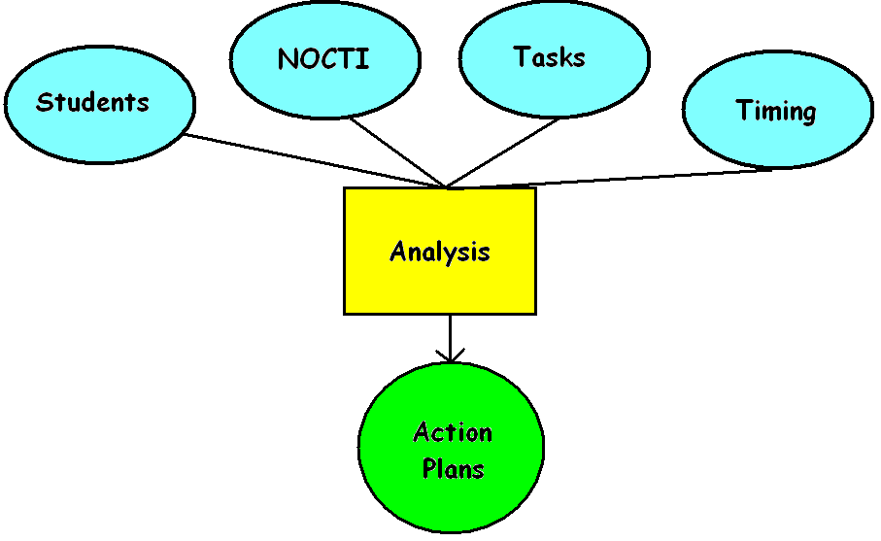
PROGRAM: Automotive Technology

NOCTI Year | PA % Advanced | CPAVTS % Advanced
2015-2016 | 59 | 62
2014-2015 | 56 | 67
2013-2014 | 58 | 89
2012-2013 | 53 | 71

Step 1: Using the Total Items Possible per Task and the Average Correct by Group, calculate the DEFICIT of your students for each NOCTI Duty Area

(TOTAL # Items Possible per Task) - (TOTAL Average Correct by Group) = Deficit

Step 2: Rank the Duty areas beginning with the one where you could potentially recover the most points.

Step 3: Describe what would be necessary to recover the lost points.

 | STEP #1 |  |  | STEP #2 | STEP #3
Duty Area | TOTAL Items Possible | TOTAL Average Correct | DEFICIT | Priority | Strategy for Recovery
Orientation | 3 | 2.2 | .8 | 7 | Okay
Safety | 10 | 8.4 | 1.6 | 5 | More safety
Tools/  Fasteners | 3 | 1.8 | 1.2 | 6 | More tools/practice
Suspension & Steering | 38 | 23.7 | 14.3 | 4 | Use of new equipment
Brakes | 44 | 23.9 | 20.1 | 3 | More intensive practice
Electrical/  Electronic Systems | 48 | 21.8 | 26.2 | 1 | More instruction/ earlier
Engine Performance | 52 | 27.8 | 24.2 | 2 | This is taught later in third year

