9TH GRADE

…IN PARTNERSHIP WITH
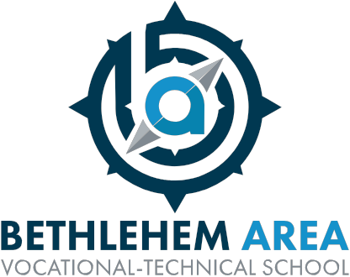

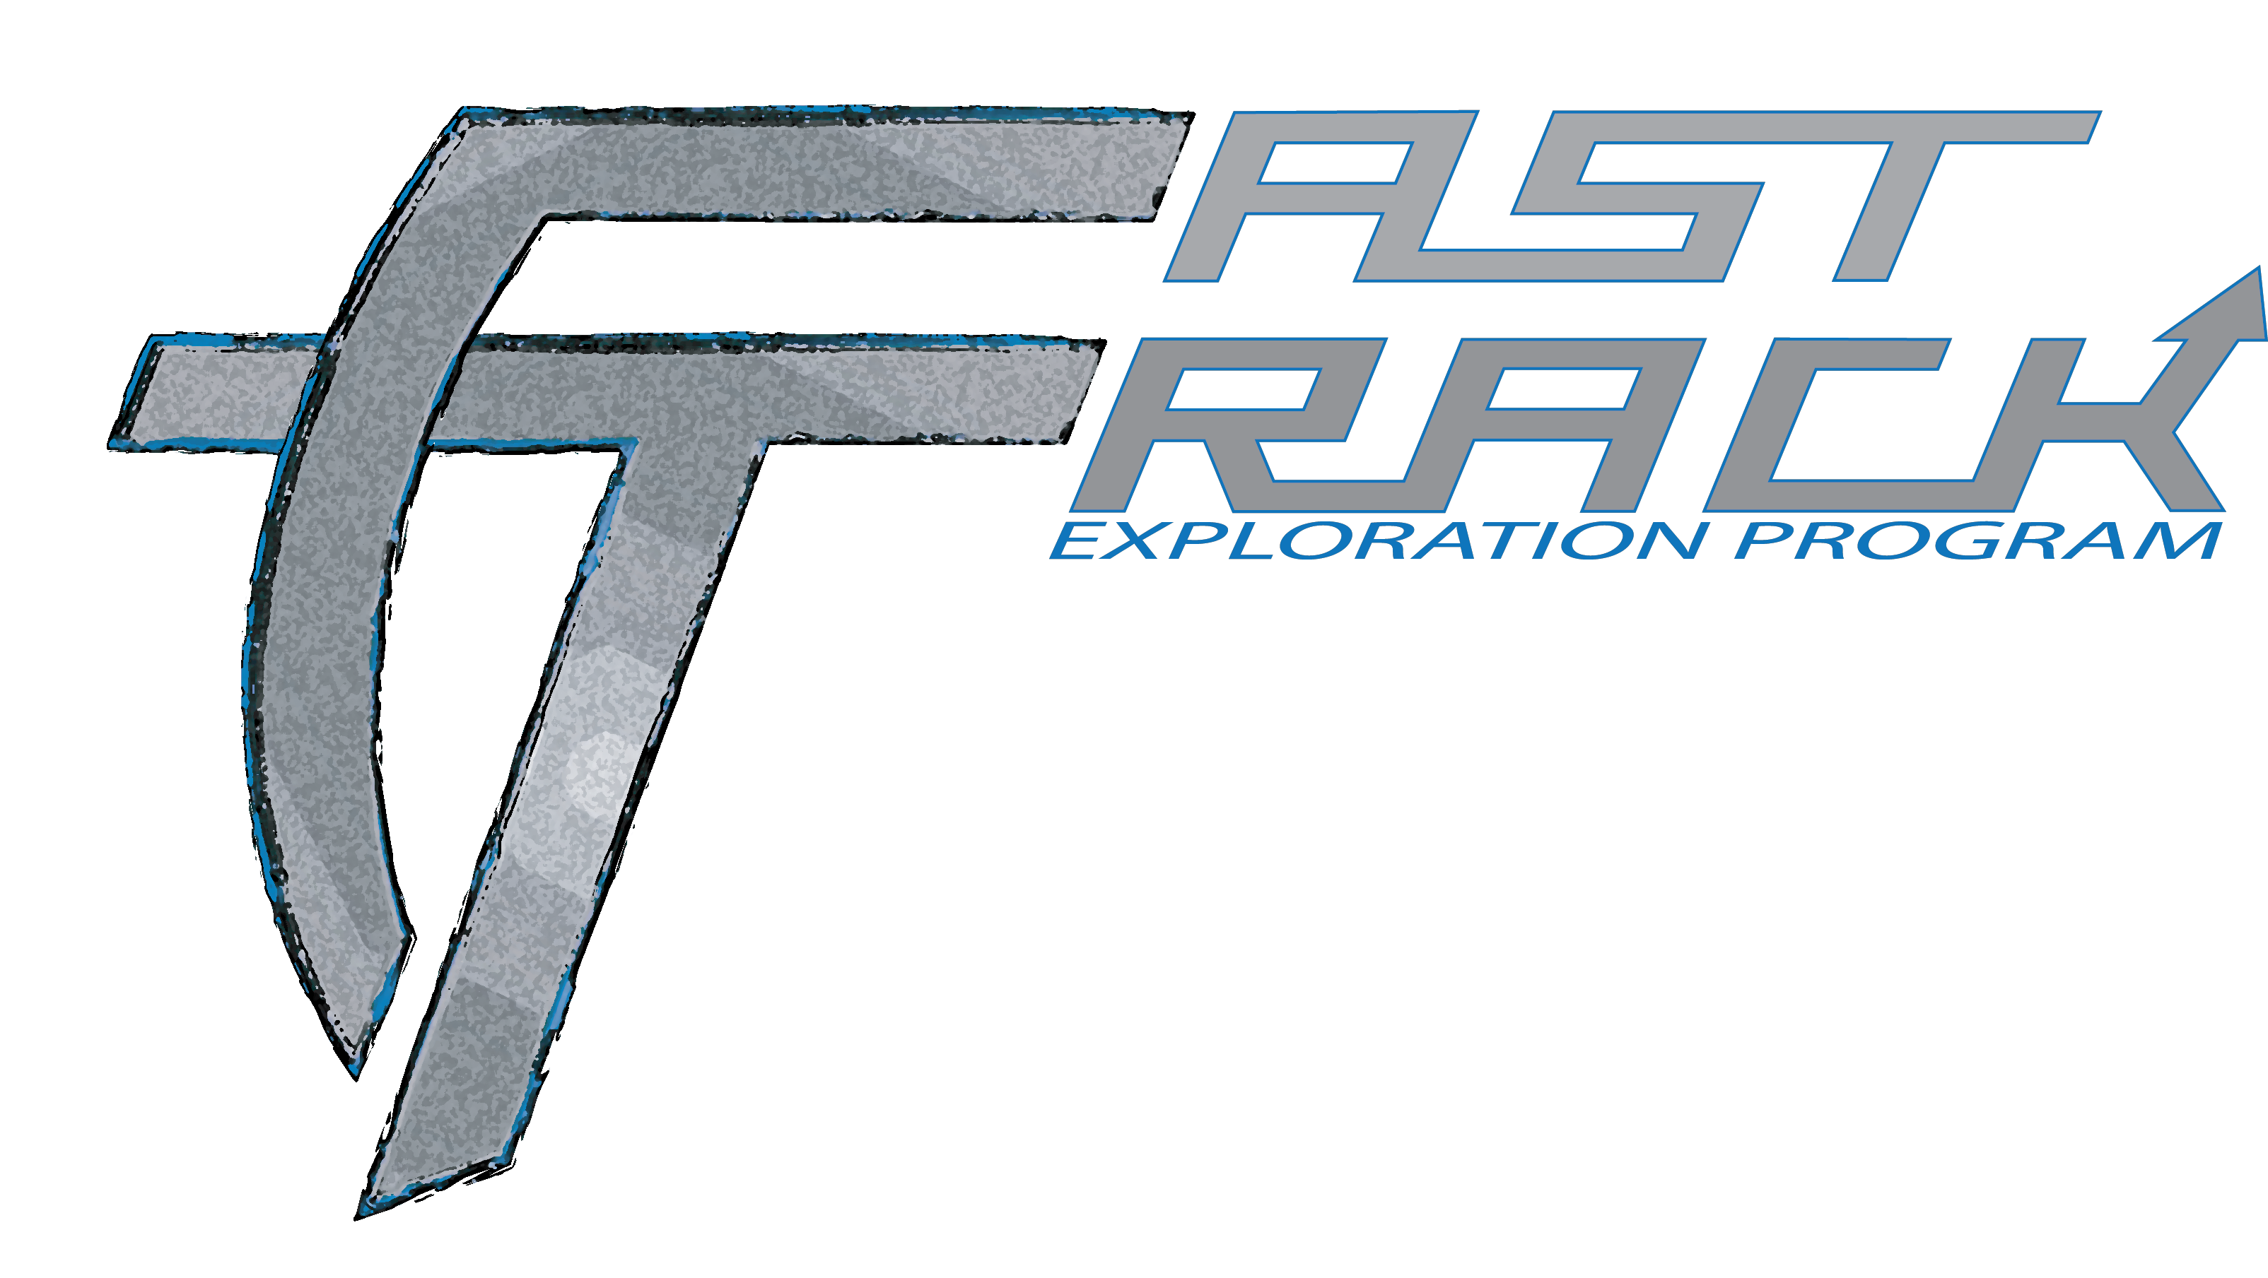

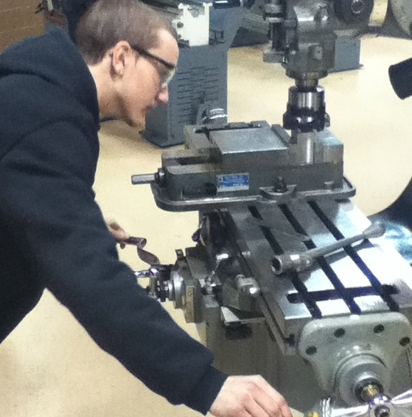

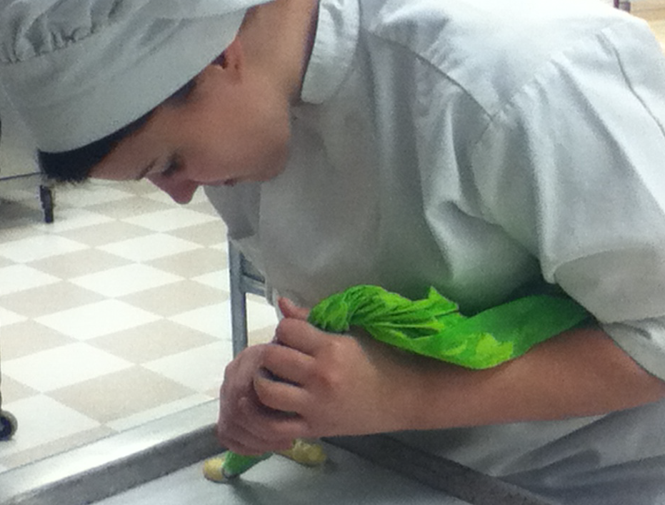

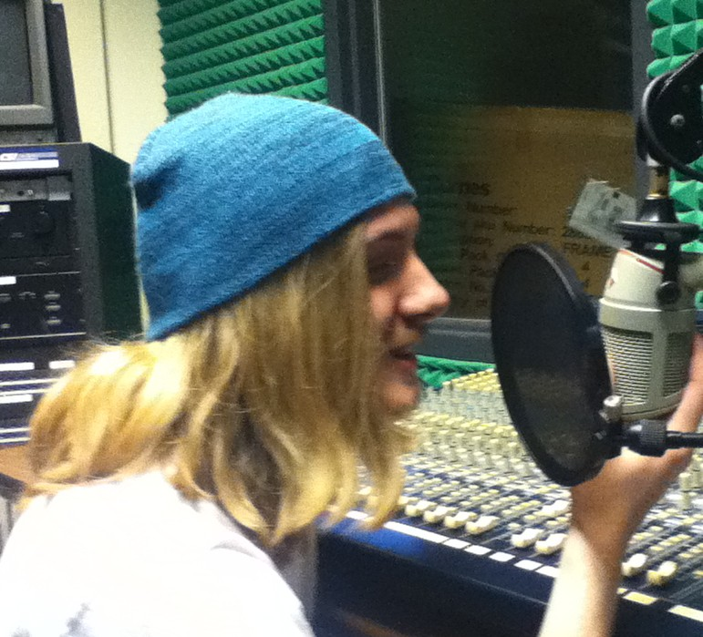

What is the Fast-Track Program?
This highly competitive program is designed to provide ninth grade students who are at or
above Grade Level standards (i.e. proficient on 8th Grade PSSA) the opportunity to attend
Bethlehem Area Vocational-Technical School during their freshman year for one (1)
semester. This is a Career Exploration opportunity for a limited amount of students!
Students will rotate through all career areas offered at BAVTS on a flex schedule during blocks 1 or 2 (Freedom) and 3 or 4 (Liberty) of their school day. By the end of the assigned semester, the students
will have an opportunity to apply for a specific program for their 10th grade year. This is different from the traditional 10th grade student schedule of rotating through four (4) programs before selecting the program of their choice. This program gives the students a clear indication and FastTrack pathway to their potential career goals at the secondary level.

The Fast-Track Rotation
9th grade students will attend BAVTS during first or second block (Freedom) and third or fourth block
(Liberty) of the 2nd semester. The first week consists of a tour of the entire school to better understand the framework of each program, career exploration projects, the creation of a personal trait brochure, and finally, program schedules. Weeks 2-11, students will be on a team of 2-3 students, explore, create and present
their experience of the assigned programs. After those exploratory weeks, students may choose one (1) to three (3) specific program(s) or continue to rotate through programs for the remainder of the semester. The last three (3) days of the semester will consist of an exit survey, scheduling decisions for 10th grade, and a short essay describing why they would like to transition into a specific program, if they so choose.

How will the Fast-Track students be graded?
Students in the FastTrack program will be assigned to a homeroom teacher who will act as their teacher of
record and rotation facilitator. The student will be responsible for gathering their performance data from the assigned program instructor, who will provide a daily work ethic grade. The form used to gather this information will be handed in every Monday for the previous week.

How do I Apply?
Students should fill out a BAVTS FastTrack Admission form and return the form to their 8th Grade Counselor.

FASTTRACK
P R O G R A M

PROGRAMS YOU WILL EXPLORE!

Construction Cluster

•Building Trades
•Carpentry
•Electrical Construction
•HVAC

•Masonry
•Plumbing

Creative Cluster

•Commercial Art
•Fashion Industries
•Graphic Communications
•Video Media Arts
•Web Design & Development

Culinary Cluster

•Baking
•Culinary Arts
Health Cluster

•Athletic Health & Fitness
•Health Careers

Manufacturing Cluster

•Electronics Technology
•Industrial Design & Advanced
Manufacturing
•Welding Technologies

Services Cluster

•Computer Networking
•Cosmetology
•Esthetics
•Protective Services

Transportation Cluster

•Auto Collision Repair
•Auto Technician

www.bethlehemavts.org • 610-866-8013
