Project Title: Heavy Equipment After-School Program
This fall, Heavy Equipment was added as a program of study at the Connellsville Area Career and Technical Center (CACTC). The Heavy Equipment After-School Program is designed for Connellsville Area School District middle school students as a way to introduce the CACTC’s newest program in a fun, interactive manner. The after-school program serves an important purpose because adolescence is a critical time for exploring career interests. Research has shown that waiting until high school to explore career choices can create anxiety and indecision. This effective model helps students better understand the opportunities that are available to them within High-Priority Occupations such as heavy equipment. Additionally, the after-school program is designed to promote nontraditional enrollment in the area of heavy equipment as students are encouraged to explore their career interests, regardless of gender, at early age. Another major benefit of the after-school program is that it ties in with the district’s Chapter 339 Plan by promoting career readiness at the middle school level. Lastly, the goal is to generate enough interest in the heavy equipment program so we would be able to offer a week-long camp in the summer.

Heavy Equipment After-School Program
When: March 6th, 8th, 13th, & 15th, 2018
Time: 3:00 p.m.-5:00 p.m.
Location: Connellsville Area Career & Technical Center
Grade: CASD 6th-8th graders
Cost: FREE! *Enrollment is limited to 15 students
Great opportunity for middle school students to experience an in-depth and hands-on exploration of the heavy equipment field!
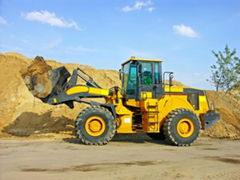

A snack will be provided!
After-School Program Features:
- In-depth exploration of the heavy equipment career path and educational training opportunities
- Instructor-led, hands-on workshops
- CAT heavy equipment simulators
- Flagger Training
- After-school program completion certificate

