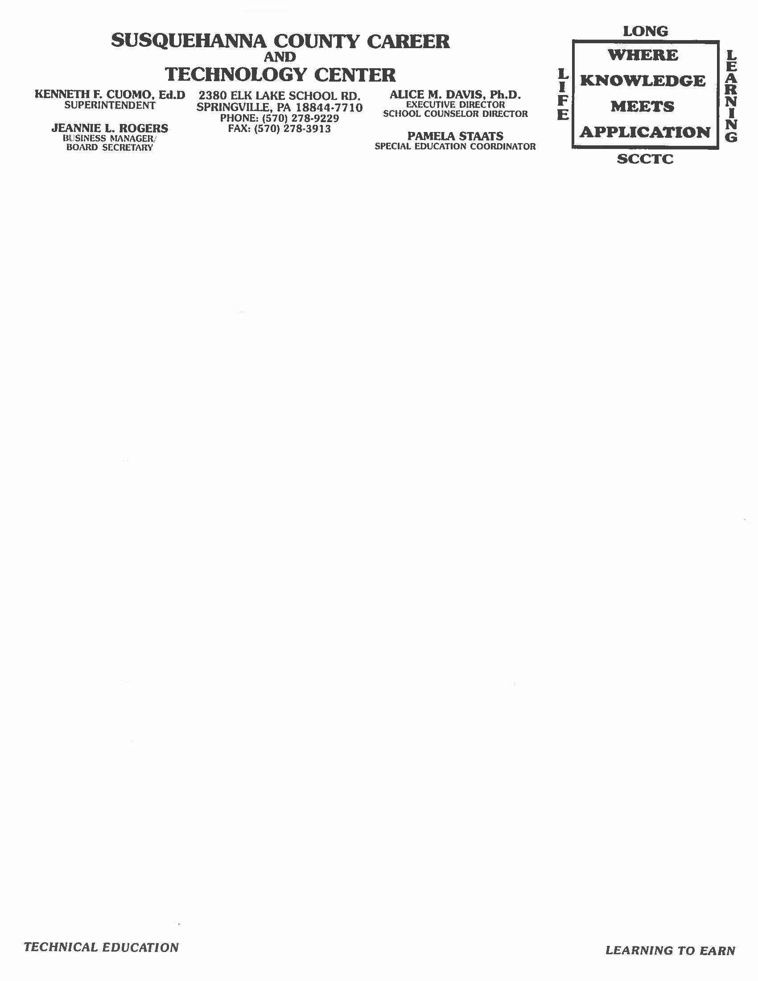

**Alert Form**  Week-Ending

(Friday________)

**The following Student’s grade has fallen below a “C”-less than 74%.**

Student: ________________________________________________________________

Program: ________________________________________________________________

School: _________________________________________________________________

Grade: ______

School Year: ___________________________

Current Grade: _______ Description: _________________________________________

_______________________________________________________________________

_______________________________________________________________________

Teacher’s Signature: ______________________________________________________

Student’s Signature: _______________________________________________________

Paraeducator(s) Signature:__________________________________________________

Administrative Director’s Signature: __________________________________________

**Plan of Action:**  ________________________________________________________________________________________________________________________________________________________________________________________________________________________________________________________________________________________________________________________________________________________________________

Date: _______ Initial: ______